Huawei Digital Power lights up Dubai and calls for collective efforts for low-carbon, smart society

Huawei Digital Power lights up Dubai with a spectacular light show on Burj Khalifa with the theme ‘Building a Low-carbon and Green Future’ which successfully concludes Global Digital Power Summit 2021 with more than 500 participants from 67 countries attending.

Huawei calls for collective actions from global customers and partners to join new Carbon Neutrality Initiative, with organizations and policy-makers from around the world backing the initiative during the summit.

- Huawei signs MoUs with Grupo IMELSA and HYBRICO Energy for strategic collaboration on clean energy and green infrastructure development.

- Huawei also signs a key contract with SEPCOIII for The Red Sea Project with 400 MW PV plus 1300 MWh battery energy storage solution (BESS), which is currently the world’s largest energy storage project.

Dubai, 17 October, 2021 – Huawei Digital Power has concluded its Global Digital Power Summit 2021 in Dubai, UAE, with more than 500 participants from 67 countries attending. As the world prioritizes carbon neutrality and post-pandemic recovery, the summit aimed to inspire collective action towards building a low-carbon and smarter society powered by digital technologies.

In the keynote speech, Charles Yang, SVP of Huawei and President of Global Marketing Sales and Services at Huawei Digital Power, said: “Carbon neutrality has become a global consensus and mission. To achieve that goal, power production needs to be low carbonized, and power consumption needs to be electrified. Huawei has deeply integrated digital and power electronics technologies to create all-scenario low-carbon energy solutions, covering the whole energy flow from green power generation to efficient power consumption.”

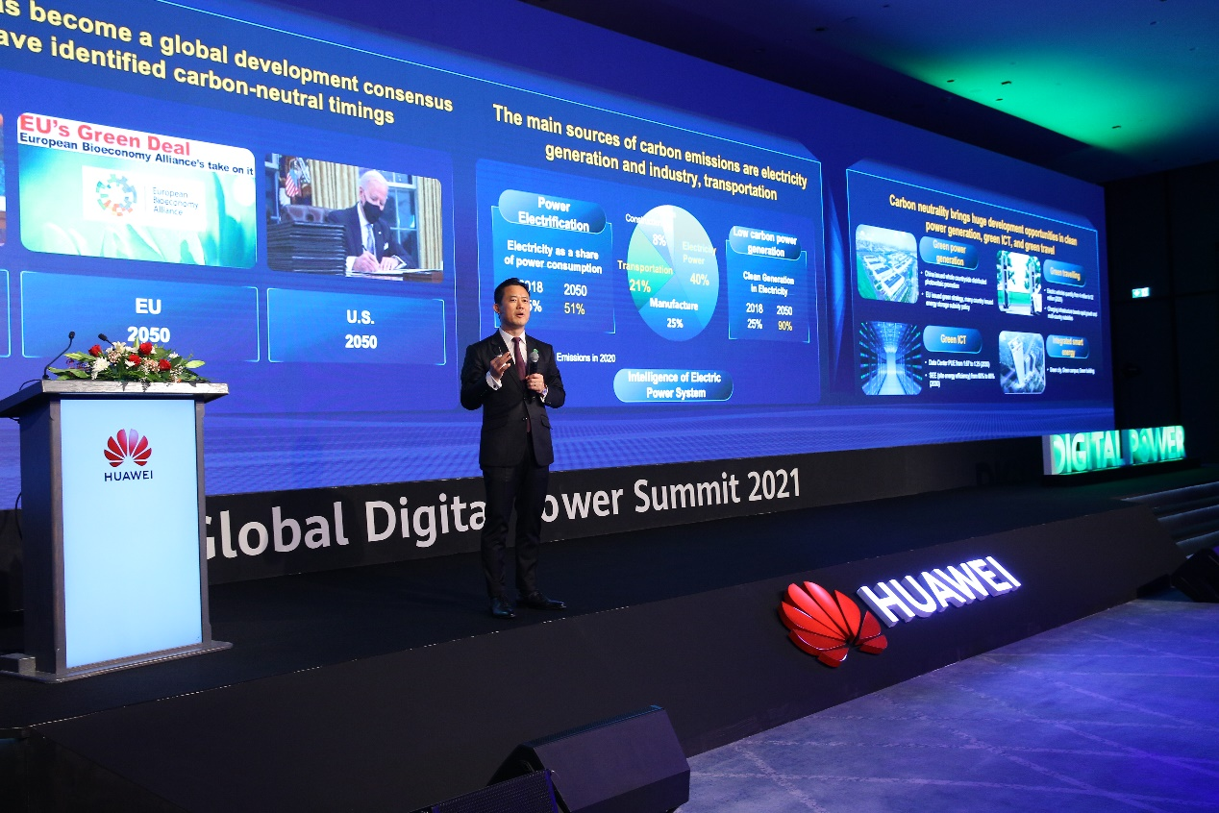

With an increasing number of countries joining the path towards carbon neutrality, the world is brimming with opportunities for investment into renewable energy and green infrastructure. At the summit, industry leaders and government officials from PV, Data Center and Site Power sectors - including Sen. Rocio Adriana Abreu Artinaño, President of the Energy Commission, Senate of the Republic of Mexico, Sanjay Kumar Sainani, Global SVP & CTO from Huawei Digital Power, Mohammad Saeed Bin Sulaiman, CEO of Data Hub Integrated Solutions LLC (MORO), Hariram Subramanian, CTO of Huawei FusionSolar, Manish Singhal, Head of Solar PV, ACWA Power, Michel FRAISSE, Vice President & CTO, Huawei Digital Power Europe, Jasem Al Marzooqi, Head of Data Centers & Telecom Facilities, Emirates Integrated Telecommunications Company, du, Prof Rabih Bashroush, Global Head, IT Infrastructure Advisory, Uptime Institute, and many more - have shared technologies, insights and policies to meet the future opportunities in renewable energy and green ICT infrastructure.

Specifically, experts from data center energy including Simon McCormick，CTO of Echelon, Seppo Ihalainen, CEO & Co-founder, Ficolo, Prof Rabih Bashroush, Global Head, IT Infrastructure Advisory, Uptime Institute and Jim Campbell, BEng (Hons) Building Services, MIET, ATD, Regional Director – RED Middle East have joined the panel discussion moderated by Sanjay Kumar Sainani. To lead the green energy transition, Amit Beriya, Director of Energy Storage & Hydrogen (BD Technical Services), ACWA Power, George Pechlivanoglou, CTO of Eunice, Ana Lia Rojas, President of EnerConnex Chile & President of the Chile Council for Women Leaders in Energy and Environment, CWEEL and Edson Uamusse, Strategic Planning Director & Chairman's Advisor, Energy Fund of Mozambique have shared their insights from the energy industry moderated by Hariram Subramanian.

Partnership for a Greener and Bright Future

Huawei Digital Power adheres to the strategy of open hardware, open-source software, and layered collaboration with industry players for a greener, brighter future. As a key part of the summit, Huawei signed memorandums of understanding with Grupo IMELSA and HYBRICO Energy for strategic collaboration on clean energy and green infrastructure development. Huawei also signs a key contract with SEPCOIII for The Red Sea Project with 400 MW PV plus 1300 MWh battery energy storage solution (BESS), which is currently the world’s largest energy storage project.

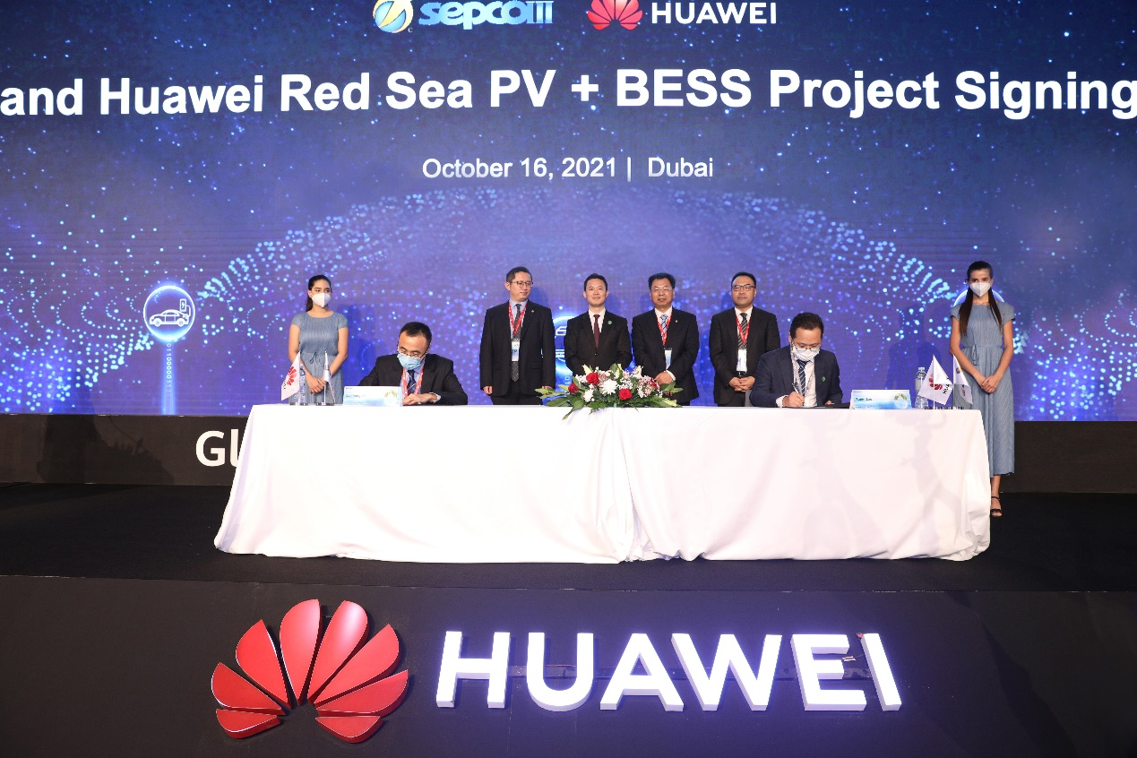

What sets Huawei Digital Power apart from peers is its unique philosophy of “Use Bits to Manage Watts”. Specifically, Mr. Yang noted how the company will use digital technologies to manage power electronics and equipment, providing simplified, green, smart, and secure solutions for clean power generation, green ICT infrastructure, transportation electrification, and integrated smart energy.

Call for Carbon Neutrality Initiative

Carbon neutrality has become a global consensus and mission. At the summit, Huawei Digital Power called for global action to pursue low-carbon and sustainable development, which requires continuous innovations, the adoption of green practices, and banding together to build an open and win-win ecosystem.

Liu Fangjiang, President of SEPCOIII International, Eaman Al Roudhan, CEO of Zain Kuwait, Sen. Rocio Adriana Abreu Artinaño, President of the Energy Commission, Senate of the Republic of Mexico, Ahmad Abdulkarim Julfar, Board Member, Executive, Managing Director at du, and Simon McCormick, CTO of Echelon, have all backed the Huawei initiative during the summit. They were joined by Mr. Yang.
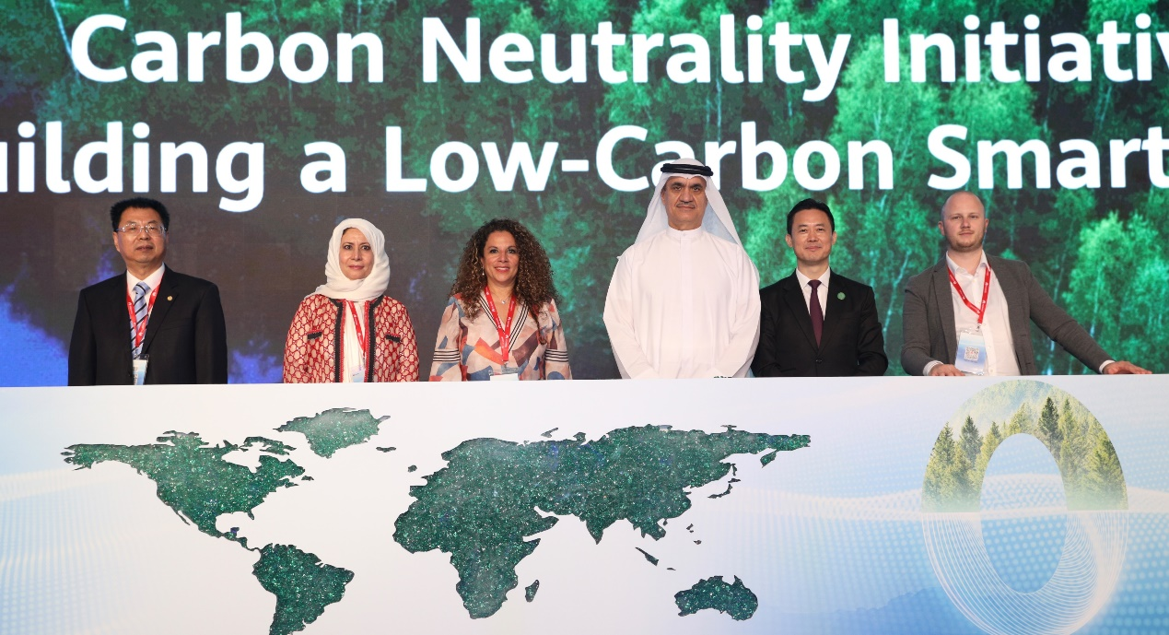

Through open collaboration and co-innovation, Huawei Digital Power and its global partners now share a commitment to fight global warming and contribute towards carbon neutrality worldwide.

Light up of Burj Khalifa to Inspire and Initiate Change
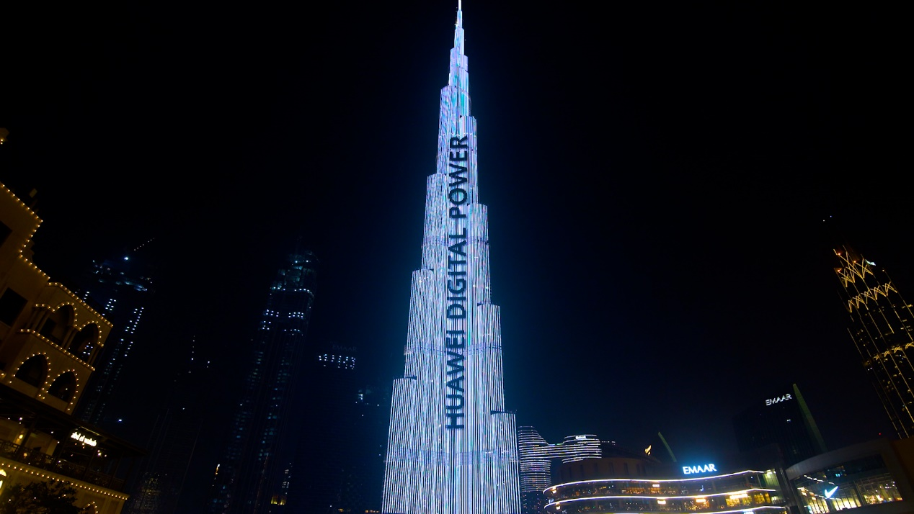
As the exciting ending of the Global Digital Power Summit 2021, Huawei Digital Power lit up Burj Khalifa, the world’s tallest building and an iconic landmark in Dubai, to inspire international communities to accelerate the green transition and build a low-carbon and smart society together.

<End>

About Huawei
Founded in 1987, Huawei is a leading global provider of information and communications technology (ICT) infrastructure and smart devices. We have more than 197,000 employees, and we operate in more than 170 countries and regions, serving more than three billion people around the world.
Our vision and mission is to bring digital to every person, home and organization for a fully connected, intelligent world. To this end, we will drive ubiquitous connectivity and promote equal access to networks; bring cloud and artificial intelligence to all four corners of the earth to provide superior computing power where you need it, when you need it; build digital platforms to help all industries and organizations become more agile, efficient, and dynamic; redefine user experience with AI, making it more personalized for people in all aspects of their life, whether they're at home, in the office, or on the go. For more information, please visit Huawei online at www.huawei.com or follow us on:
http://www.linkedin.com/company/Huawei
http://www.twitter.com/Huawei
http://www.facebook.com/Huawei
http://www.youtube.com/Huawei

