Huawei Global Digital Power Summit 2021 set to open on October 16 in Dubai

- Huawei Global Digital Power Summit 2021 is set to open on October 16 in Dubai with more than 300+ individuals attending the physical event, including executives from Dubai Electricity & Water Authority (DEWA), Group42, ACWA Power, du, Uptime Institute and Engie.

Huawei to announce joint actions across the energy and ICT industry chain to unlock green energy potential for a low-carbon smart society.
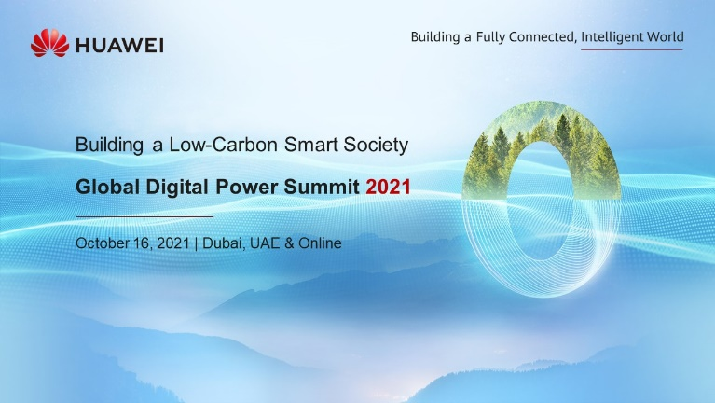

Dubai, 8 October, 2021 - To help organizations worldwide get better prepared to seize opportunities arising from a carbon-neutral world, Huawei Digital Power will hold the Global Digital Power Summit 2021 in Dubai, UAE, on October 16th. The summit recognizes that the race to net-zero is on, and that the target of carbon neutrality truly requires a global coalition and international actions. The selection of Dubai, UAE, to host the summit also reflects the importance of the Middle East region to Huawei’s global digital power business.

Earlier this year, Huawei Digital Power Technologies was established to accelerate energy digitalization and decarbonization. The company aims to integrate digital and power electronics technologies to accelerate clean energy generation, to build green transportation, sites and data centers, as it focuses on building a better and greener future.

In the post-COVID world, green economic recovery has garnered significant attention as world leaders are eager to bring economies out of recession through a redesign to reduce greenhouse gas emissions and increase the resilience of infrastructure and communities. To date, 137 countries from the UN Climate Convention — responsible for 80% of global emissions — have committed to net-zero-emission targets. The key to carbon neutrality is the development of a new power system.

With a focus on digital innovations for a low-carbon and smart world, the summit will bring together energy policymakers, industry professionals in the data center, ICT and renewable energy sectors, and executives from across the world to discuss the challenges and opportunities of sustainable development and digital transformation.

At the upcoming summit, Charles Yang, the newly-appointed President of Global Marketing, Sales and Services, at Huawei Digital Power, will kick off the event, highlighting Huawei Digital Power’s commitment to building a low-carbon smart society. Yang is appointed to the new role having previously served as President of Huawei Middle East.

An exciting lineup of speakers from global industry players and Huawei partners such as Dubai Electricity & Water Authority (DEWA), Group42, ACWA Power, du, Uptime Institute and Engie will share their own best practices, success stories, and use cases in improving energy efficiency via digitalization.
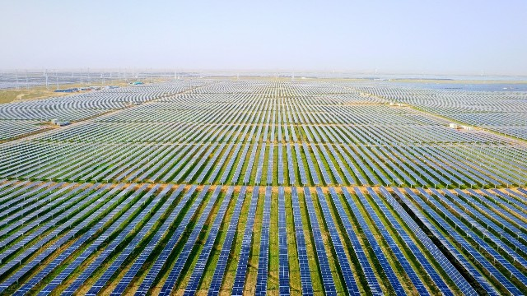
Huawei Digital Power Contributes to the Successful Grid Connection of World's Largest PV Plant at China's Qinghai Province with its Smart PV Solution

It’s undeniable that no single company can succeed in the energy transition alone. Now more than ever, building a sustainable and low-carbon future requires joint actions and collaboration from across the energy, business, and government ecosystem. Thus, the summit puts a spotlight on the Huawei-backed ‘Call to Action’ statement that calls for energy industry companies around the world to set coordinates towards a net-zero energy sector.

For the first time in history, Huawei believes that everyone can participate in a step-change in efficiency, and the rare opportunity to reconcile the paradox between progress for all and a sustainable future for our planet. The company is thus committed to working with its customers and partners to build low-carbon and smart energy systems.

Huawei will also have a full-on live stream experience of the summit. Registration for the online event can happen here.

<End>

About Huawei
Founded in 1987, Huawei is a leading global provider of information and communications technology (ICT) infrastructure and smart devices. We have more than 197,000 employees, and we operate in more than 170 countries and regions, serving more than three billion people around the world.
Our vision and mission is to bring digital to every person, home and organization for a fully connected, intelligent world. To this end, we will drive ubiquitous connectivity and promote equal access to networks; bring cloud and artificial intelligence to all four corners of the earth to provide superior computing power where you need it, when you need it; build digital platforms to help all industries and organizations become more agile, efficient, and dynamic; redefine user experience with AI, making it more personalized for people in all aspects of their life, whether they're at home, in the office, or on the go. For more information, please visit Huawei online at www.huawei.com or follow us on:
http://www.linkedin.com/company/Huawei
http://www.twitter.com/Huawei
http://www.facebook.com/Huawei
http://www.youtube.com/Huawei

