Immediate release
20 September 2021

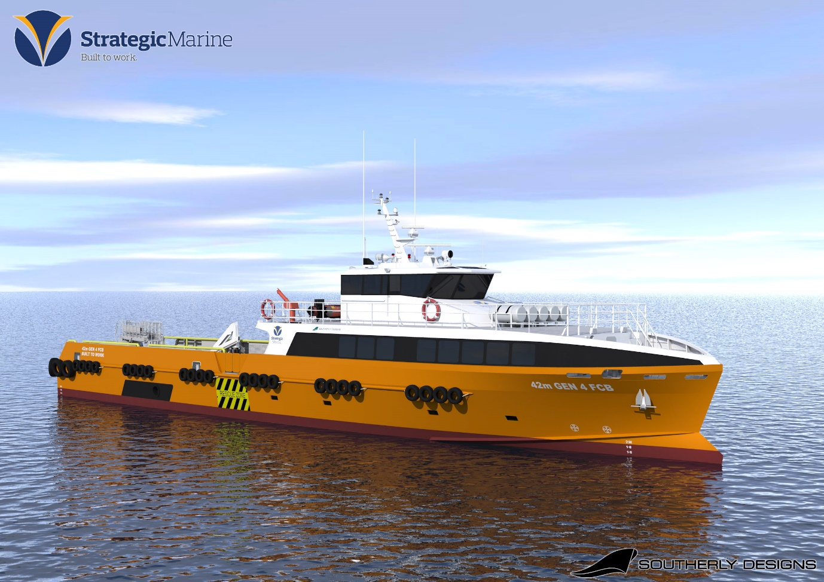
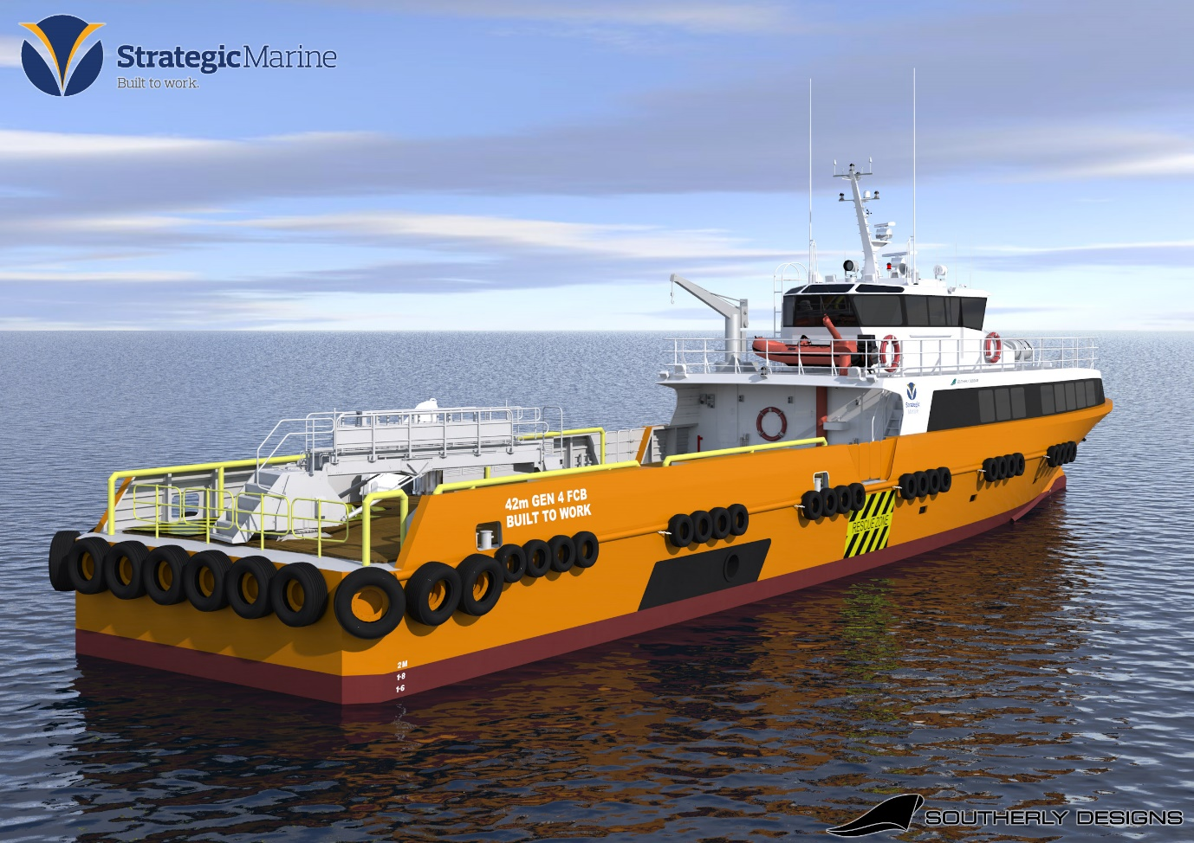

Strategic Marine announces new 42m Gen 4 Fast Crew Boat

- New design offers expanded operating capabilities, lower emissions and fuel efficiency
- Enhanced safety and comfort features from previous generations
- Options include motion compensated gangway, gyro-stabilizer and semi-autonomous system

Strategic Marine (S) Pte Ltd has announced the launch of its new Aluminium 42m Gen 4 Fast Crew Boat (FCB) design. The vessel comes with a highly efficient new hull form and Z-bow which improves seakeeping, requires less power for the same speed and deadweight (DWT), reducing fuel consumption and lower emissions.

The new hull form has been developed in collaboration with Southerly Designs with CFD analysis and optimization by Seaspeed Marine Consulting. It has been put through comprehensive model testing at the Australian Maritime College to further verify and validate the performance predictions. These extensive test results confirm that the hull resistance is reduced by over 8% compared to the Gen 3 hull form. Furthermore, the new vessel incorporates design enhancements based on feedback from operators, improving on the performance of Strategic Marine’s extremely successful Gen 3 design which was launched in2014.

The new Gen 4 FCB is 42m in length, with cargo carrying capacity of 190DWT, a clear deck area of 140m², a cargo deck area of 120m² and a deck loading capacity of 2.5 tonnes/m². It has business class seating capacity for between 80 and 100 passengers with space for 12 crew in seven berths and one medical room/office.

The wheelhouse has been increased in size for optimum comfort and visibility and the main passenger super structure area has been fitted with maximum size windows with improved positioning to provide excellent passenger visibility, reducing motion sickness.

An optional gyro stabilizer significantly reduces the vessels rolling motion, increasing safety and efficiency during personnel transfers, the gyro coupled with an optional motion compensated gangway gives the ultimate level of safety for personnel transfers to the offshore installation. The vessel can also be fitted with an autonomous control module for either local or remote autonomous operations.

The Gen 4 FCB can be fitted with three Cummins KTA 50 M2 engines, delivering clean and efficient power of 4,026kw (5,400hp). The vessel can deliver a service speed in excess of 30 knots @ 85% MCR with a full speed of 32 knots @ 100% MCR and the fuel consumption at service speed is approximately 827 litres/hr (3 engines).

Chan Eng Yew, CEO of Strategic Marine, said: “Strategic Marine has considerable experience in building boats for this market having been doing so since 2001, with more than 70 fast crew boats delivered.
Each new vessel design is based on our goal of continuous improvement, whilst exceeding our customers’ needs, operationally and environmentally. The latest Gen 4 design is Strategic Marine’s answer to the increasing operational demands of not only our clients, but the environment too.“

The Gen 4 FCB dimensions
- Length overall 42 metres
- Beam (max) moulded 8.20 metres
- Depth moulded 3.75 metres
- Hull baseline design draft (approx.) 1.90 metres
- Propeller draft max (approx.) 2.10 metres
- GRT (approx.) 317
- Max deadweight 190 tonnes (increased from 105 tonnes)
- Clear deck area 140m² (increased from 120m²)
- Cargo deck area 120m² (increased from 100m²)
- Deck loading capacity 2.5 tonnes/m² (increased from 2.0tonnes/m²)
- Fuel oil 84.2m³
- Fresh water 33.0m³
- Black/grey water 0.5m³

The Gen 4 FCB can be equipped with the following options:
- Motion compensated gangway
- Deck crane
- GYRO stabilizer
- Active ride control
- SCR System for IMO tier III compliance
- Hybrid propulsion options
- Biosafe notation
- Twin bow thrusters
- Bow boarding
- Ballistic protection
- DP1
- Semi-autonomous control
- Fire Fighting Systems

The vessel has already achieved “Approval In Principle” with Lloyds, BV and RINA, but can be classed with any other IACS classification society.

Alongside shipbuilding, Strategic Marine provides service and maintenance, fabrication and engineering, marine logistics services and financial services and solutions for its products – providing a turnkey, end-to-end solution for its clients.

For Sales and Technical enquiries, please email: sales@strategicmarine.com.

###

About Strategic Marine:
Strategic Marine Group is a leading specialist shipbuilder with a yard in Singapore, managing a shipyard in Vietnam and presence in Australia and the United Kingdom. It operates principally in five key market segments, producing high quality vessels for Oil & Gas, Renewable Energy, Ferries & Transportation, Defence and Paramilitary and Port / Pilot Services.

Strategic Marine Group has built and delivered more than 600 vessels made of both aluminium and steel for a variety of clients in the maritime, offshore and defence sectors. Strategic Marine’s solid reputation is based on building high-performance vessels on time and on budget.

Visit the website here: www.strategicmarine.com

For more information on this press release, please contact:

Helix PR
Corporate Communications Advisors to Strategic Marine
Claire Sneddon – csneddon@navigatepr.com 00 44 782 447 8058
Katy Ng – katy.ng@helixpr.asia +65 6222 6375

