Morningstar Corporation’s Advanced Solar Technology Helps Oil & Gas Production Facilities Reduce Carbon Emissions

‘Digital oilfields’ are going solar to reduce carbon emissions, minimize maintenance, and
maximize power availability for efficiency and safety

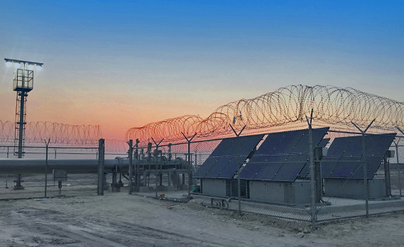
Morningstar Corporation’s solar charge controllers are installed in EcoSol Energy’s projects for Kuwait Oil Company, the 10th largest oil company in the world. The solar-plus-storage systems safely and reliably power new lighting systems for remote oil production facilities.

Newtown, PA, USA, Sept. 20th, 2021 - Morningstar Corporation announced today its TriStarTM solar charge controllers are installed in a group of solar-plus-energy storage systems for major oil companies in locations around the globe. The advanced technology of the TriStar controllers was selected because it delivers the highest level of performance, safety, and reliability for these types of mission-critical solar power systems. As ESG (environmental, social, and governance) becomes a more mainstream concern for CEOs, and carbon emissions mandates grow around the world, oil and gas companies are finding ways to reduce their carbon footprints. The solar power generation systems deliver a dependable and efficient source of power for the remote and often challenging conditions of oil production facilities. The solar-plus-storage systems keep production online while significantly reducing facilities’ carbon emissions.
“As oil production facilities seek to transition to solar power, Morningstar’s long-standing global track record assures companies that we are a partner they can rely on,” commented Lee Gordon, President, and Founder, Morningstar Corporation.

EcoSol Energy installed solar-plus-storage systems on oil fields in Kuwait to power lighting systems that keep the facilities running safely and efficiently. Scotland-based JCE Energy designed, engineered, and tested solar-plus-storage systems that power a range of applications and devices on offshore wellhead platforms from the North Sea to the Java Sea. Orga BV outfitted wellhead platforms with solar-plus-storage in the Gulf of Thailand focusing on making systems highly reliable and compact to deliver overall cost savings for clients. Swift Energy completed the installations of solar-plus-storage systems to power remote data gathering on wellheads on the Pemanis project offshore Sarawak in East Malaysia. All systems were installed with Morningstar Corporation controllers either suitable for or certified in Hazardous Area Zone use. Morningstar’s newest solar chargers are Hazardous Location certified in North America (with UL/CSA) and Internationally/Europe (with IECEx/ATEX).
Subject to harsh conditions and hazardous operations, several brands of charge controllers require manual resetting. Sending teams out to remote platforms for manual restart is a dangerous and expensive job. Remco Vonk, General Manager Asia & Pacific, Orga BV commented, “The high efficiency nature of Morningstar products is uniquely suited for our needs. They are compact and perform in the high-temperature conditions experienced when they are incorporated into our explosion-proof control systems installed in certified enclosures. Most importantly, they have proven to be ’fit and forget’. With Morningstar, we know we won’t have to go back for expensive service calls”.

The solar + storage systems deliver power for remote oil production, platform, and facilities operations. The systems reduce the oil and gas facilities’ carbon footprint and long-term energy costs while delivering reliability in power to keep operations online, safe and productive. Learn more about how solar provides power for some of the largest oil companies in the world: Dependable, Cost-Effective Electrical Power, High Efficiency Solar Based Solutions, Optimal Efficiency in Tight Spaces, and Full Reliable Charge in Extreme Temperatures.

About Morningstar Corporation
With over 4 million products installed and sold since 1993—in some of the most extreme environments and mission-critical applications in the world—Morningstar Corporation is the world's leading supplier of solar controllers and inverters. The US-based, employee-owned company is headquartered in Newtown, Pennsylvania, with an engineering research and development center in Maryland, and a global network of dedicated, best-in-class distribution and manufacturing partners. For more information visit www.morningstarcorp.com.

