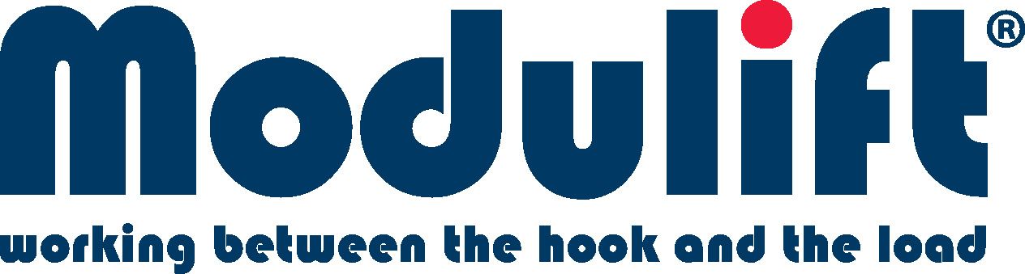

News release
September 2021

Modulift, a technical expert and manufacturer in the lifting industry based in the UK, have added a new product to its portfolio which is specifically designed for 3-point lifts and suitable for circular lifts.
The TriMOD, designed by their in-house engineering team and manufactured in their established factory in Poole, Dorset is a triangular frame, designed for 3-point lifts. The frame can be extended for 6-point lifts and multipoint circular lifts due to the unique shape. All TriMOD corner units are compatiable with Modulift spreader beams to achieve multiple spans.
The efficient design makes the rigging configuration simpler, easy to assemble and cost effective. Due to the shape, it can be used for circular lifts, in particular when lifting tank roofs and pressure vessels, avoiding uneccessary cascading rigs.
John Baker, Commercial Director said, “We are continually looking for new ideas and developing new products. We recently attended Vertikal Days in Peterborough and brought a TriMOD demo along with us. The feedback we received was phenomenal, everybody loves the product and how unique it is. It was good to see everybody again, especially after a testing 18 months for the lifting industry and for us, it was great to come back to our first event with a brand new product.”
Harshal Kulkarni, Engineering Manager for Modulift added, “Our team have wanted to develop a product which would change the lifting industry and in particular, design and manufacture a product which is suitable for complicated circular lifts. We have seen an increase in enquiries over recent months and we’re proud to be able to offer a solution for our customers.”

ENDS.

Contact:
Natasha Russell, Marketing Executive
Natasha.russell@modulift.com
+44 (0) 1202 621511

Notes to editors:

About Modulift

Modulift is an innovative engineering company that provides technical expertise alongside the manufacture and supply of specialist lifting equipment that is tested and certified to the highest worldwide standards.

The company, established since 2002, produces high quality lifting and spreader beams, spreader frames and other ‘below the hook’ lifting equipment, that is used globally across the heavy lifting industry. Sectors provided include wind energy, nuclear, construction, and the oil and gas industries.

Headquartered in Dorset, UK, Modulift offers a complete engineering lifting service, including unique integrated lifting analysis with all products, available off-the-shelf or custom designed to meet a client’s specific requirements.

Its goods and services are delivered through a number of routes including direct end user, resellers, rental partners and a global distribution network.

