Huawei Wins WWF Climate Solver Award 2020

BEIJING, Sept. 24, 2021 -- Climate Action Week - 2021 Zero Carbon Mission International Climate Summit (hereinafter referred to as "the Summit"), co-organized by World Wide Fund for Nature (WWF) and Phoenix TV, was held in Beijing on September 22. At the event, Huawei Technologies Co., Ltd. (hereinafter referred to as "Huawei") won the WWF Climate Solver award 2020 for its world leading FusionSolar Smart PV solution.

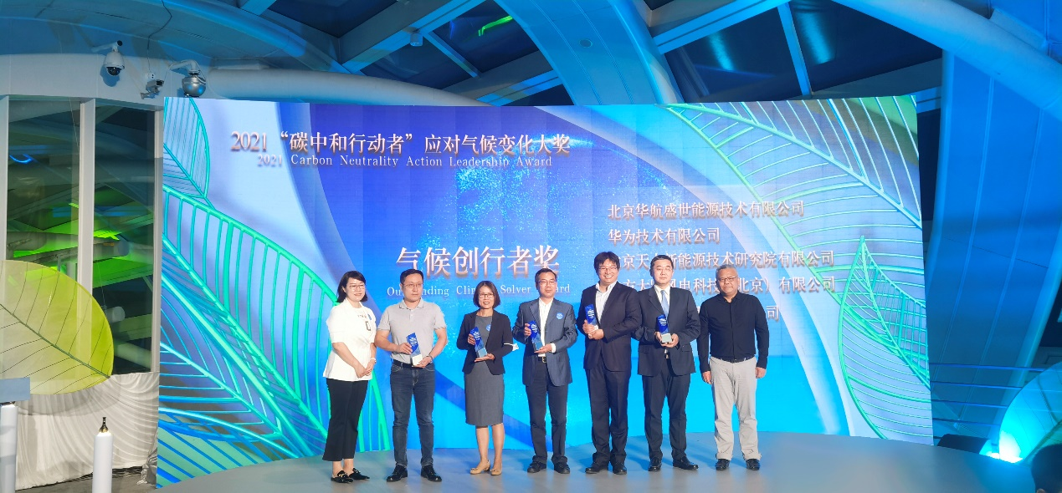

This year's Summit officially launched the annual Carbon Neutrality Action Leadership Award, which, based on the Science Based Targets initiative (SBTi) and the UN-supported Race to Zero initiative, was designed to recognize individuals, teams and projects with outstanding performance in business commitment, innovation in technology, actions that produce results, and impactful communications, with the aim of encouraging companies to take actions that help mitigate climate change, driving various industries to set up emission reduction targets, and setting an example for taking such actions.

The Carbon Neutrality Actor - Climate Solver of the Year award is a key component of the Carbon Neutrality Action Leadership Award, and is based on the WWF Climate solver program, an annual program launched in China in 2011. It aims to create favorable conditions for the promotion of climate technologies with revolutionary potential by identifying and selecting innovative low-carbon technologies, so as to contribute to the realization of the goal of keeping global average temperature rise below 2℃.

Since its launch in 2011, the award has recognized 34 innovative low-carbon technologies. Applications for the 2020-2021 Climate Solver Award opened in December 2020 and closed in March of this year. After rigorous compliance review, primary election, two rounds of evaluation by experts, accounting of emission reduction potential and on-site replies, the Huawei FusionSolar Smart PV solution was selected as the winner from a host of candidates.

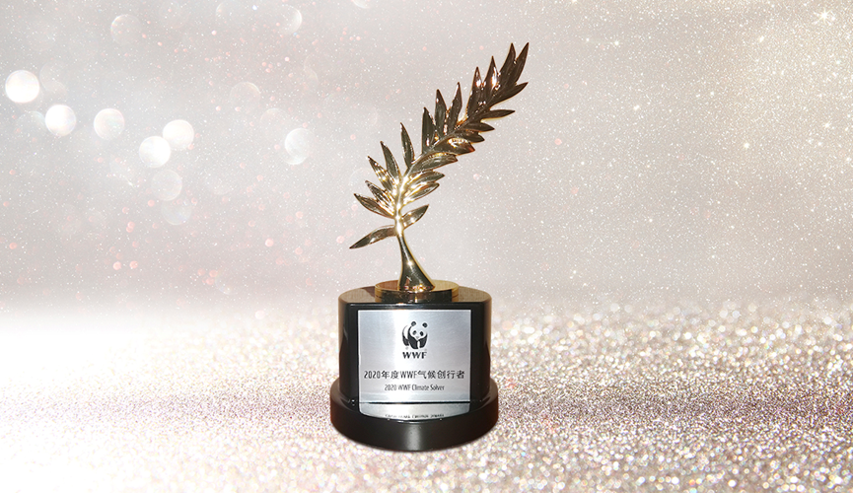

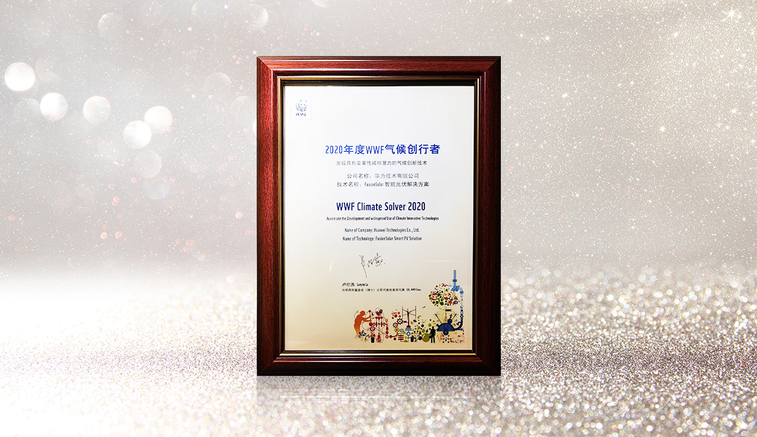
This year's selection criteria were particularly stringent. The on-site reply session examined not only the level of technical advance (20%), the economics (20%) and the maturity (15%) of the candidate technologies, but also their ecological and environmental benefits, growth potential and social benefits, accounting for 20%, 15% and 10% of the overall score, respectively.

As of June 30, 2021, Huawei Digital Power had helped customers generate 403.4 billion kWh of electricity with green energy, saving 12.4 billion kWh of electricity consumption and reducing CO2 emissions by 200 million tons, equivalent to planting 270 million trees.

The Summit, under the theme of "Global Carbon Neutrality and China's Role", invited more than 70 guests, including Al Gore, former Vice President of the United States; Tu Ruihe, the representative of UNEP China Office; Jia Feng, Director of the Center for Environmental Education and Communications of the Ministry of Environmental Protection; and Marco Lambertini, Director General of WWF International, to discuss topics including global carbon neutrality, corporate resolve for achieving climate goals, green finance, energy transformation, green building and low-carbon transportation. The event aims to bring together resources, fully mobilize corporate engagement in addressing climate change, and provide diverse guidance and services such as strategic planning, technology application, results demonstration, knowledge sharing and international exchanges for local governments and enterprises to achieve the goals for peak CO2 emissions and carbon neutrality.

About Huawei
Founded in 1987, Huawei is a leading global provider of information and communications technology (ICT) infrastructure and smart devices. We have more than 197,000 employees, and we operate in more than 170 countries and regions, serving more than three billion people around the world.
Our vision and mission is to bring digital to every person, home and organization for a fully connected, intelligent world. To this end, we will drive ubiquitous connectivity and promote equal access to networks; bring cloud and artificial intelligence to all four corners of the earth to provide superior computing power where you need it, when you need it; build digital platforms to help all industries and organizations become more agile, efficient, and dynamic; redefine user experience with AI, making it more personalized for people in all aspects of their life, whether they're at home, in the office, or on the go. For more information, please visit Huawei online at www.huawei.com or follow us on:
http://www.linkedin.com/company/Huawei
http://www.twitter.com/Huawei
http://www.facebook.com/Huawei
http://www.youtube.com/Huawei

